Mini Spell Checker

Formal Report

A basic spell checking C#.NET GUI using Levenshtein distance

Introduction to Algorithms
COEN 4650 – Spring 2013
Professor: Dr. Xin Feng
Marquette University

Table of Contents
A basic spell checking C#.NET GUI using Levenshtein distance 1
1. System Features 1
2. User’s Manual 2
3. Technical Details 5
3.1 Overall Design 5
3.2 Load dictionary 6
3.3 Load File with Misspelled Words 7
3.4 Levenshtein distance 8
3.5 Make Suggestions 9
4. Test Plan 9
4.1 Verifying selection 10

System Features
The program functions as a basic spell checker.
It has the functionality to…
- Read in a text file and create a dictionary from all the words separated by a whitespace.
- Read in a text file to have each word checked against the dictionary.
- Find all the misspelled or missing words against the dictionary based on it’s Levenshtein distance
- Provide possible replacement matches of correct spelling.
- Allow the user to “see” where his/her mistakes are in real-time viewing. The misspelled words are turned red to distinguish them.

Known issues/Future Improvements
- Since the file-to-dictionary conversion ignores symbols, consonants such as “can’t”, don’t”, etc are viewed as two words.
- There is no “replace” button to replace the misspelled word with the correct suggestion. The words’ indexes are stored before the replacement feature so when they replace a word with a different length, words begin to overlap.
- After the file is being checked against the dictionary, any words added to the dictionary after that fact are not checked in the file unless the file is reloaded.

User’s Manual
The program is simple in its functionality. There are a total of four buttons which relate to an important part in the spell checking process.

- First, you must browse for a file that will be used as your dictionary…Press the “Browse” button.
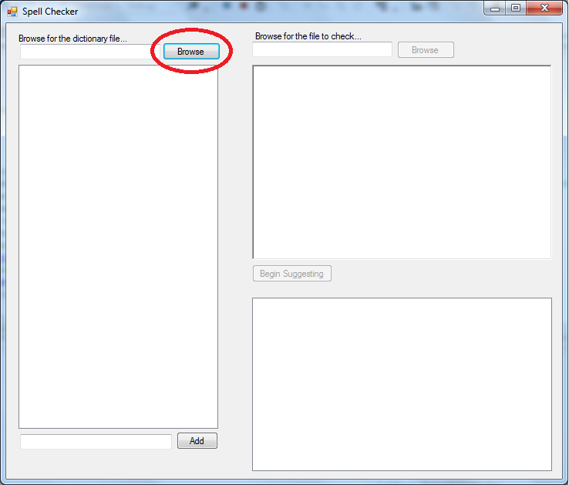

- Add any words to the dictionary at this point before you load the file by entering them into the textbox below and pressing “Add”
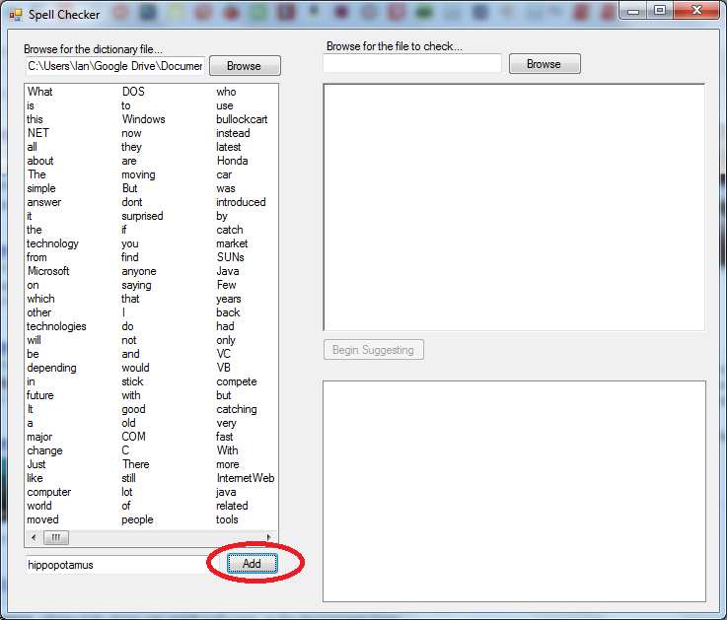
- Once the dictionary is loaded, the second browse button should be enabled where you can open up a file that you are trying to check against the dictionary. Do this by pressing “Browse” and load the file…
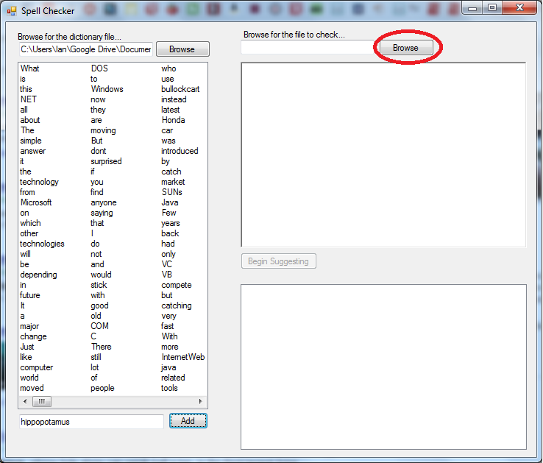

- Once the file is loaded, you can press the “Begin Suggesting” to check the file for any misspelled words and to suggest possible replacements.

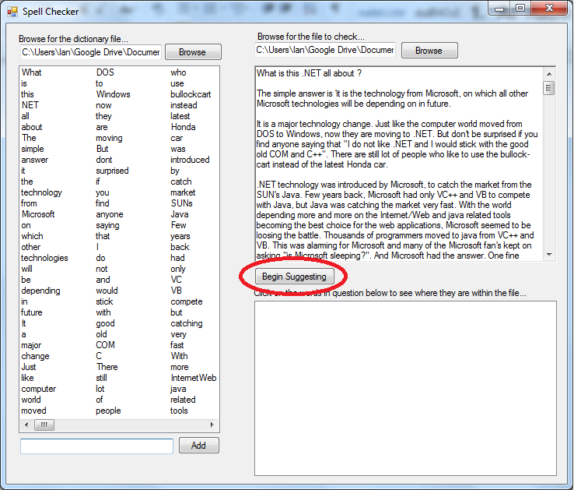
- Then the suggestion box will populate and the misspelled words will become red. As you click on each word in the suggestion box, the corresponding word in the file will be highlighted
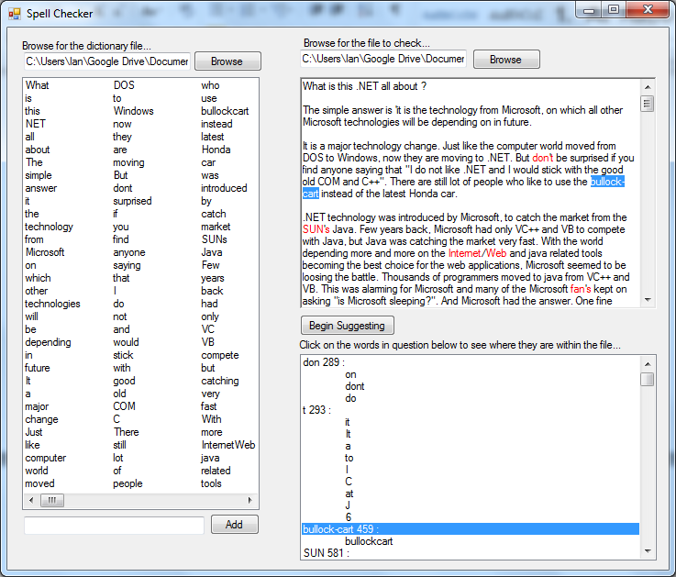

Technical Details
The following will be a breakdown of the design approach and of the code.

Overall Design
Each lane here represents a main step (in order) of the user experience and behind the scenes what is happening.
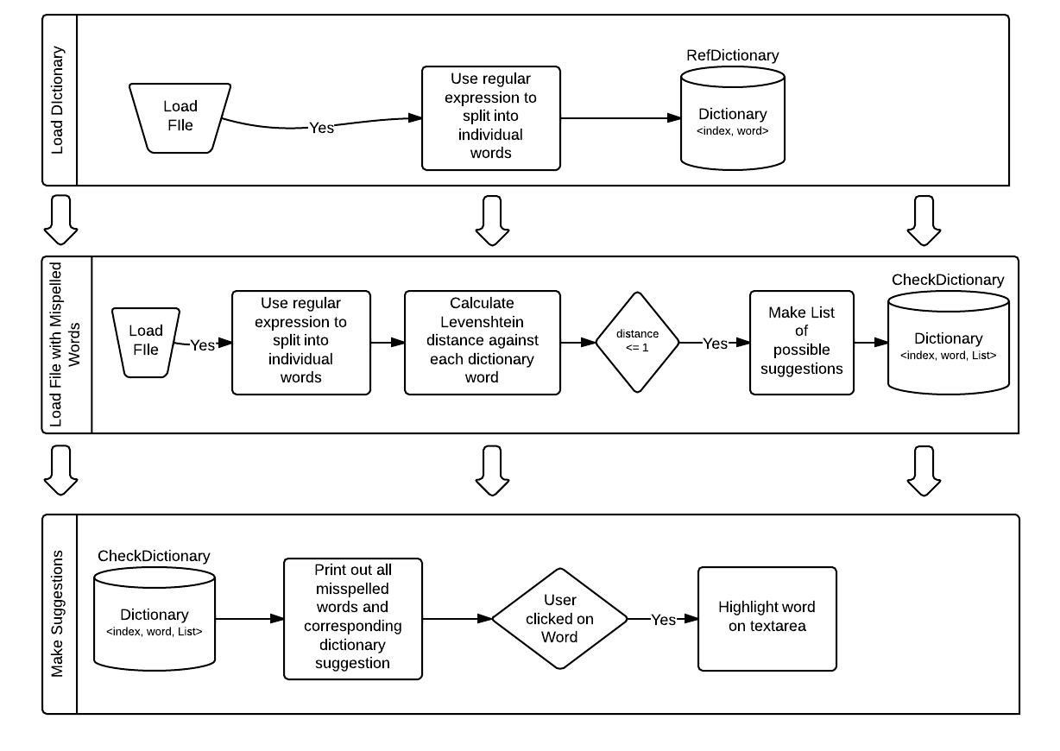

Load dictionary

Selecting the File, Streaming it
First, the file must be selected by using a fileDialogBox. Once the location is specified, We create a StreamReader to readToEnd() and place the information within a String here denoted as Dictionary.
private void button1_Click(object sender, EventArgs e)
{
checkButton.Enabled = true;
DictionaryFileDialog.Filter = "txt files (*.txt)|*.txt|All files (*.*)|*.*";
if (DictionaryFileDialog.ShowDialog() == System.Windows.Forms.DialogResult.OK)
{
System.IO.StreamReader sr = new
System.IO.StreamReader(DictionaryFileDialog.FileName);
//MessageBox.Show(sr.ReadToEnd());
Dictionary = sr.ReadToEnd();
sr.Close();
DictionaryTextBox.Text = DictionaryFileDialog.FileName;
CreateDictionary(Dictionary);
}
}

Making the dictionary
We then take the string created and split it up into an array of words separated by the character ‘ ‘. This is done simply with the Split() method. Once this is created, we loop through the array, remove any symbols, double check if it’s empty and then add it to the dictionary dentoed as dictionary. At the same time, we add the word to listView1 so the user can see all the words that have been added.
private void CreateDictionary(String ASCII)
{
string[] t = ASCII.Split(new[] { ' ' }, StringSplitOptions.RemoveEmptyEntries);
dictionary = new Dictionary<int, string>();
for (int i = 0; i < t.Length; i++)
{
t[i] = stripSymbolsFromString(t[i]);

if (!dictionary.ContainsValue(t[i]) && t[i] != "")
{
dictionary.Add(i, t[i]);
listView1.Items.Add(new ListViewItem(t[i]));
}

}
}

Load File with Misspelled Words
The file is first loaded as stated above.
The dictionary is created in different way however. In this method, we are using results as the dictionary file and stores a KeyValuePair<String, int> as its Key and a List<int> as its value. The KeyValuePair (denoted as wordToCheckPair) stores each word as its String and the index it is found in the whole file as int.
Each word is checked against the dictionary. For Each word that is not in the dictionary already, we check it’s Levenshtein distance and if it is of 1 or less then we add it to the possible words in the List (denoted as dictionaryKeys).

private void checkMisspelledWords()
{
results = new Dictionary<KeyValuePair<String, int>, List<int>>();
List<int> dictionaryKeys = new List<int>();
Dictionary<int, String> wordsToCheck = makeDictionary(richTextBox1.Text);
foreach (KeyValuePair<int, String> word in wordsToCheck)
{
if ((!dictionary.ContainsValue(word.Value)))
{
dictionaryKeys = new List<int>();
foreach (KeyValuePair<int, String> dictionaryKey in dictionary)
{
if (LevenshteinDistance(word.Value, dictionaryKey.Value) <= 1)
{
dictionaryKeys.Add(dictionaryKey.Key);
}
}
KeyValuePair<String, int> wordToCheckPair = new KeyValuePair<String, int>( word.Value, word.Key);
results.Add(wordToCheckPair, dictionaryKeys);
}
}
}

Levenshtein distance
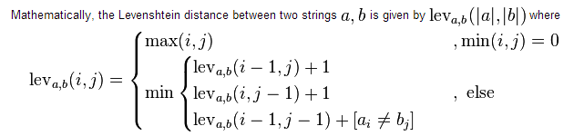
The following code was implemented:
// <summary>
// Calculates the Levenshtein distance between two strings--the number of changes that need to be made for the first string to become the second.
// </summary>
// <param name="first">The first string, used as a source.</param>
// <param name="second">The second string, used as a target.</param>
// <returns>The number of changes that need to be made to convert the first string to the second.</returns>
// <remarks>
// From http://www.merriampark.com/ldcsharp.htm
// </remarks>
public static int LevenshteinDistance(string first, string second)
{
if (first == null)
{
throw new ArgumentNullException("first");
}
if (second == null)
{
throw new ArgumentNullException("second");
}

int n = first.Length;
int m = second.Length;
var d = new int[n + 1, m + 1]; // matrix

if (n == 0) return m;
if (m == 0) return n;

for (int i = 0; i <= n; d[i, 0] = i++)
{
}

for (int j = 0; j <= m; d[0, j] = j++)
{
}

for (int i = 1; i <= n; i++)
{

for (int j = 1; j <= m; j++)
{
int cost = (second.Substring(j - 1, 1) ==
first.Substring(i - 1, 1) ? 0 : 1); // cost
d[i, j] = Math.Min(
Math.Min(
d[i - 1, j] + 1,
d[i, j - 1] + 1),
d[i - 1, j - 1] + cost);
}
}

return d[n, m];
}

Make Suggestions
This is the last step where the user presses the suggest button. We loop through the results dictionary (as seen above) and select each word at its index and change its color to red. Then we populate the ListBox (denoted as suggestionbox) with all of the words and possible suggestions (stored in the Value field of the results dictionary).
private void SuggetionButton_Click(object sender, EventArgs e)
{
foreach (KeyValuePair<KeyValuePair<String, int>, List<int>> k in results)
{
richTextBox1.Select(k.Key.Value, k.Key.Key.Length);
richTextBox1.SelectionColor = Color.Red;

String theString = k.Key.Key+" "+k.Key.Value+" : "+Environment.NewLine;
suggestionbox.Items.Add(theString);
foreach (int index in k.Value)
{
theString = "\t" + dictionary[index] + Environment.NewLine;
suggestionbox.Items.Add(theString);
}
}

}

Test Plan
The testing was fairly straightforward as there was a GUI to provide visual feedback of what the results where. As stated in the System Features section, there are a few known issues that were found through testing.

Verifying selection
Below you can see the correct selection of misspelled words as none of them are found in the dictionary to the left. The biggest known failure is the fact that words with contractions are ignored. This may be possible remedied by using a more accurate regular expression.
